CS 255 System Design Document

UML Diagrams

UML Use Case Diagram
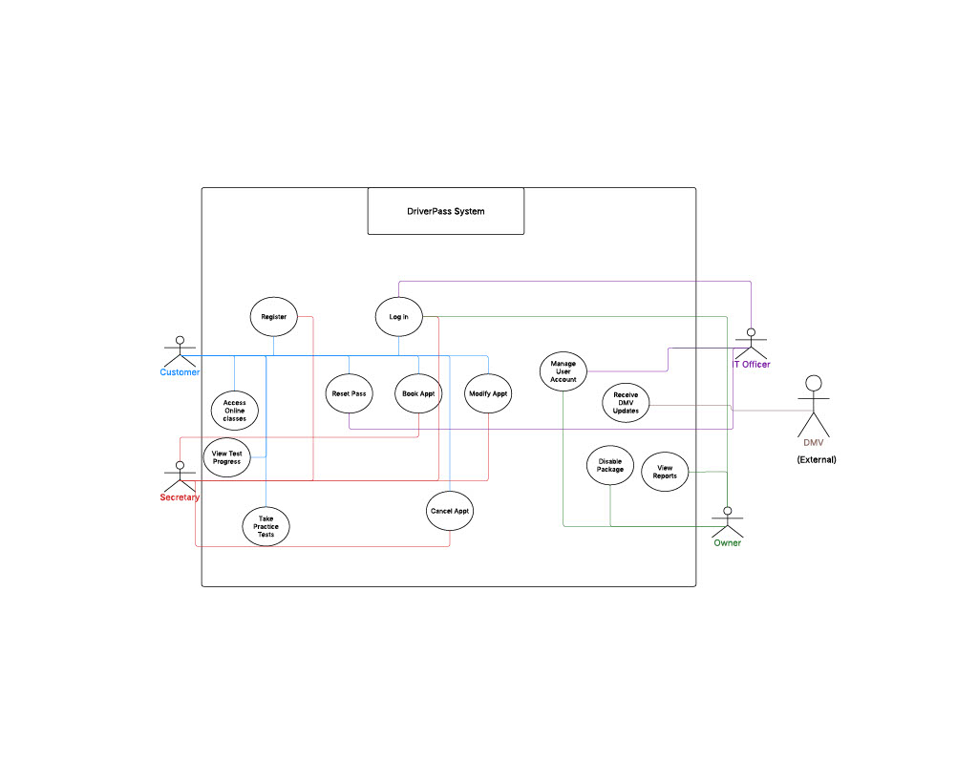

UML Activity Diagrams
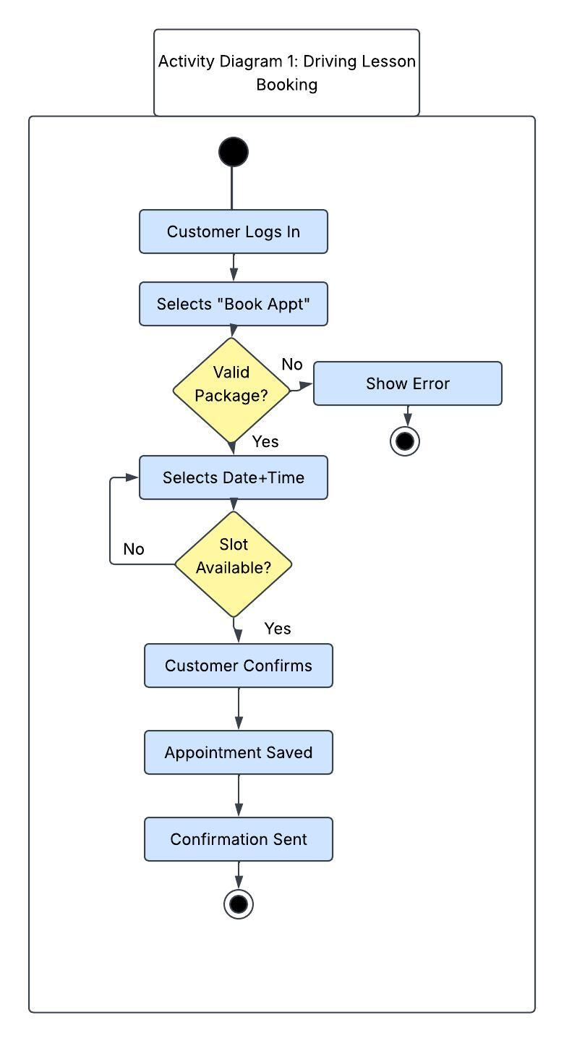
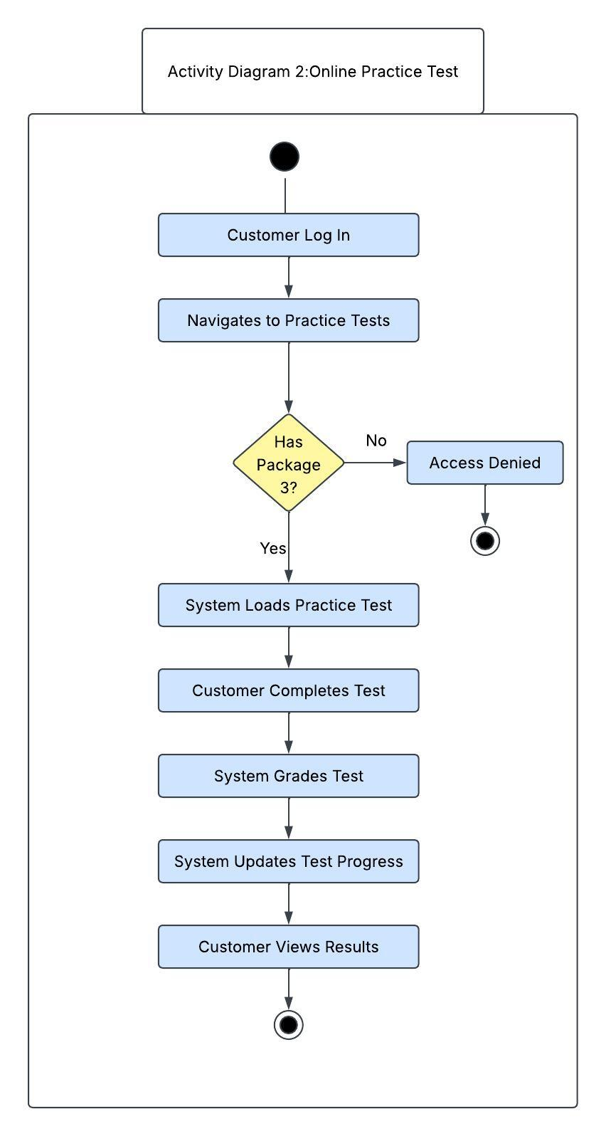

UML Sequence Diagram
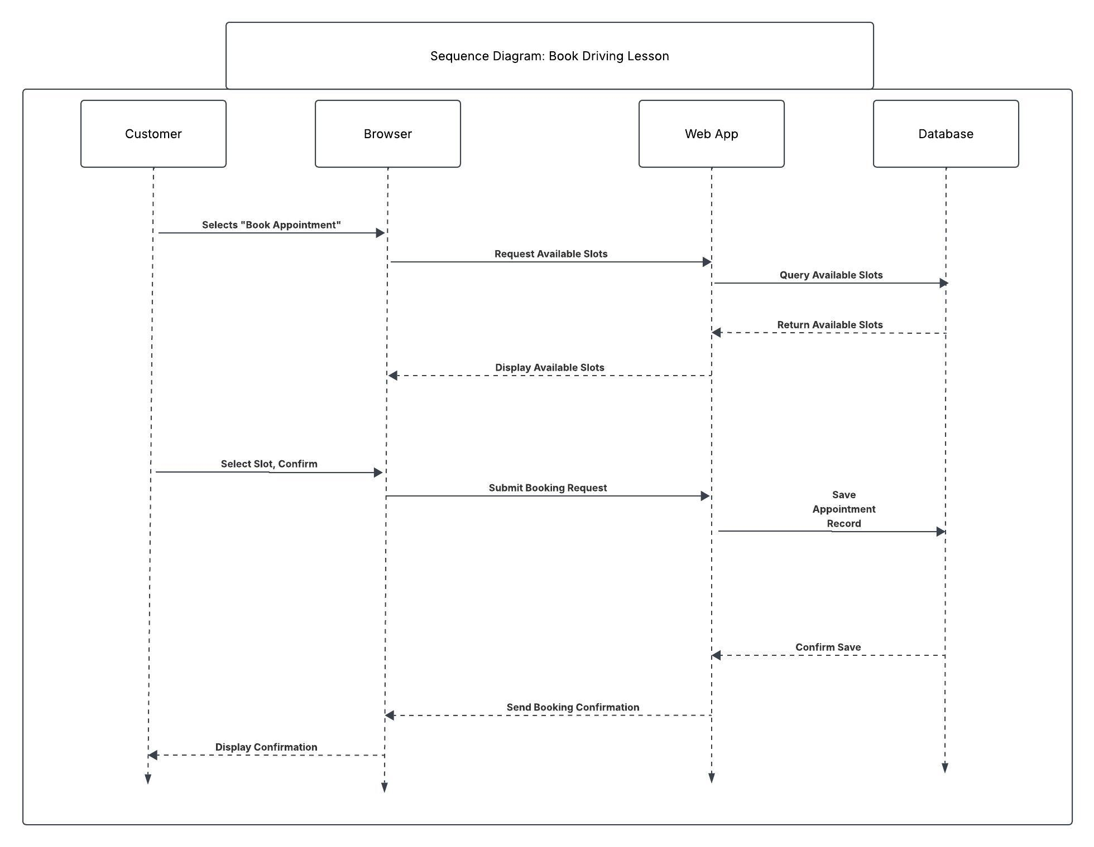

UML Class Diagram
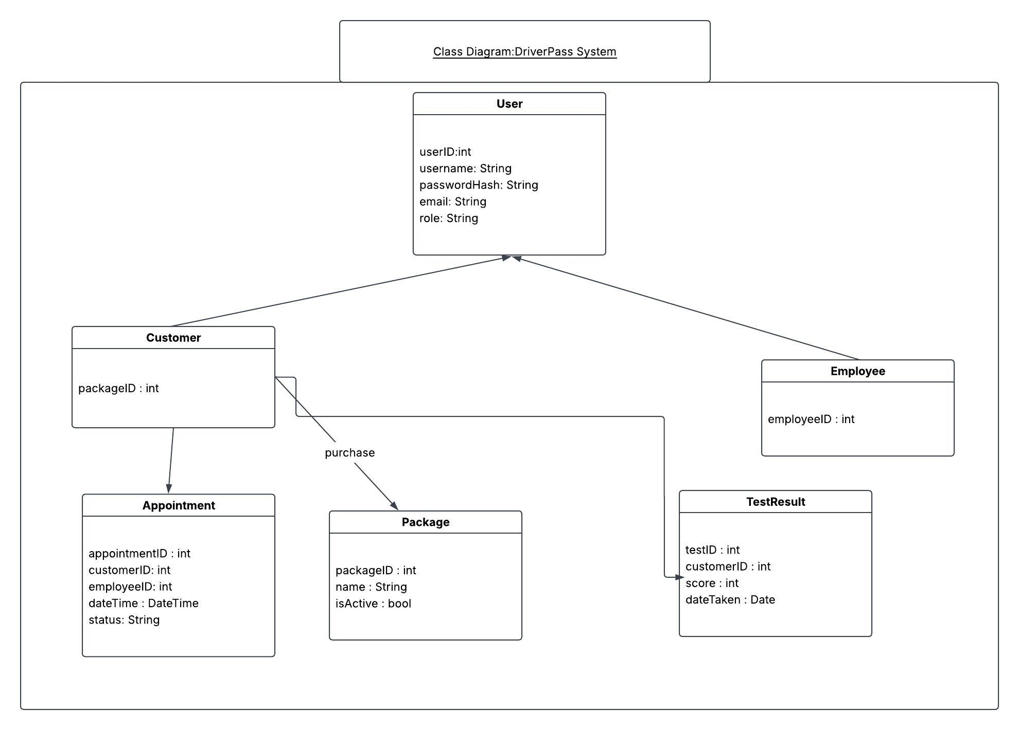

Technical Requirements

The DriverPass system will be built as a cloud-hosted web app, meaning that users will be able to access it from any browser, on any device, without the need to install anything. To keep up with booking and online training demands, the application must be able to handle multiple users smoothly, and all communication between users and the server should be encrypted. Hosting in the cloud removes the need for any on-site server management, and the provider will handle uptime, backups and so forth. User accounts, appointments, packages, test results, driver notes, and activity logs will be stored in a relational database. Package purchases will be processed with a third-party payment service in order to keep the system PCI-compliant without the need to build payment infrastructure from scratch.
In terms of software, the system must support four distinct user roles at launch: Owner, IT Officer, Secretary and Customer. Access permissions must be enforced for each of these roles. Appointment confirmations and password resets will be handled through an automated notification system. Staff should be able to download reports and data as excel or CSV files, facilitating the offline access requested by the owner. Since DMV rules and training materials will need updating from time to time, authorized staff will be able to make those changes through a content management interface rather than relying on a developer.

